Task 3.1: Implementing Dynamic Features with JavaScript
Overview
In this Touchstone task, you will begin adding simple dynamic behavior to your webpages using JavaScript. You will use click events to display alert messages when users interact with different buttons and form elements. These features introduce the basic JavaScript skills that you will continue developing in later Touchstone tasks.
You will complete the following:
- Add a JavaScript alert for the Subscribe button in the footer of every webpage.
- On the Gallery page, add alert messages to the Add to Cart, Clear Cart, and Process Order buttons. These buttons act as placeholders for features you will build later. For this task, each button only needs to display a simple alert when clicked.
- On the About Us/Contact page, add a JavaScript alert to the Submit button on the contact form.
Each alert should activate through a click event and display one of the following messages:
• “Thank you for subscribing.”
• “Item added to the cart.”
• “Cart cleared.”
• “Thank you for your order.”
• “Thank you for your message.”
Finally, document any issues or errors you encountered while developing your code. Remember that any component colors, font colors, and typography styling should be consistent with your choices in Task 1 and should be appropriate according to the client description provided in the Client Scenario and Criteria.

Instructions
Provide your responses in the following table.

Rendered Subscribe Feature Alert Window Screenshot
Hint: Provide a screenshot showing the alert message that appears when the user clicks the Subscribe button.
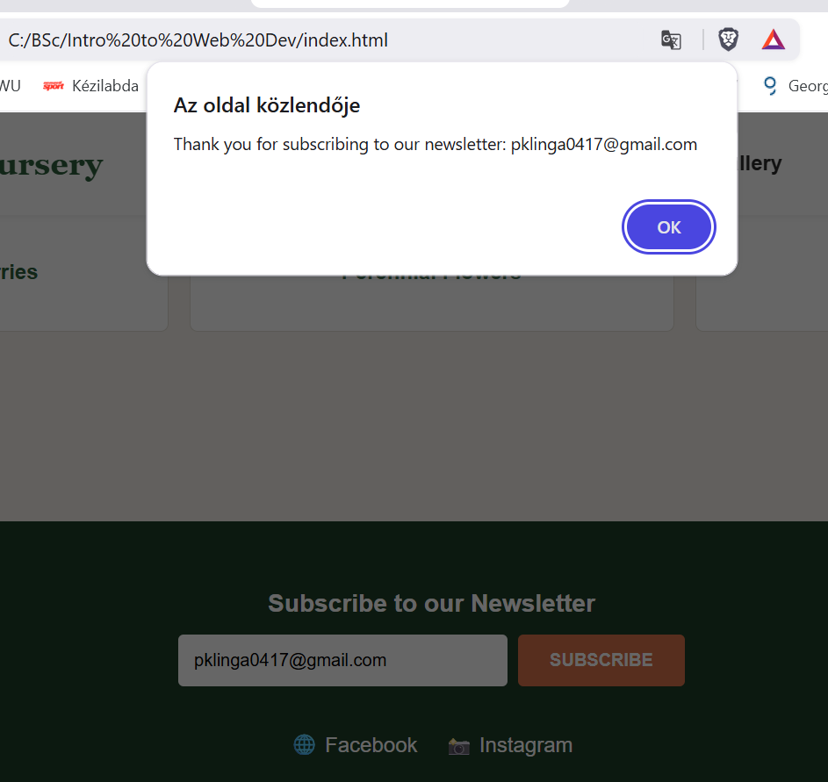

Subscribe Feature Alert Window Analysis
Hint: Briefly describe how you implemented the Subscribe button alert.
The newsletter submission logic is handled via the initNewsletter() module. Instead of raw click mapping on a passive button, an event listener intercepts the submit event of the #newsletter-form. This allows the system to validate inputs automatically using native browser mechanics before halting the default submission loop via e.preventDefault(). Upon successful intercept, the event handler triggers an alert window displaying a custom string alongside the dynamic parameter: alert("Thank you for subscribing to our newsletter: " + emailInput.value);.

Rendered Add to Cart Button Alert Screenshot (Gallery Page)
Hint: Provide a screenshot showing the alert message that appears when clicking any “Add to Cart” button on the Gallery page.
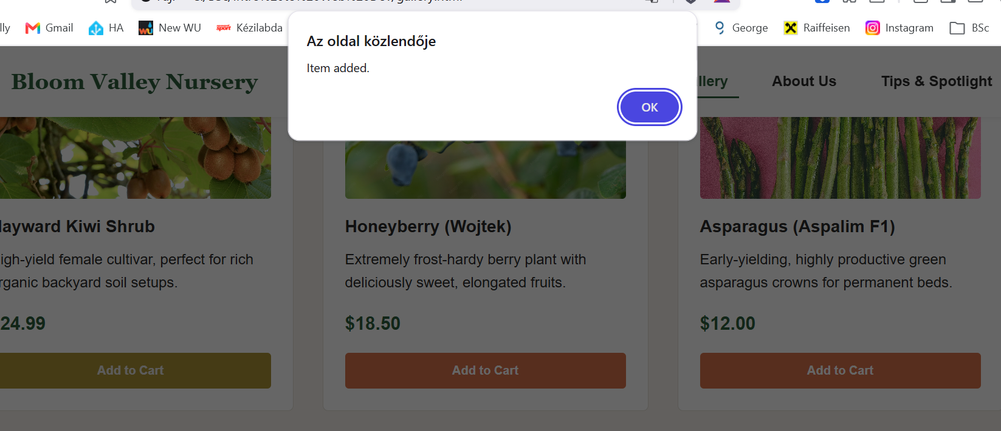

Add to Cart Button Analysis
Hint: Describe how JavaScript is applied to the Add to Cart button. Remember: no shopping cart logic is required.
The shopping cart functionality is fully orchestrated inside the initShoppingCart() module. Plant cards on the Gallery page trigger click listeners attached to elements matching the .add-to-cart-btn class selector. The module reads metadata attributes embedded directly within the HTML markup (data-id, data-name, data-price), updates the application array, persists the updated state to the user's browser storage, and executes the required alert("Item added."); call to signal operation completion.

Rendered Clear Cart Button Alert Screenshot (Gallery Page)
Hint: Provide a screenshot showing the alert message that appears when clicking the “Clear Cart” button.
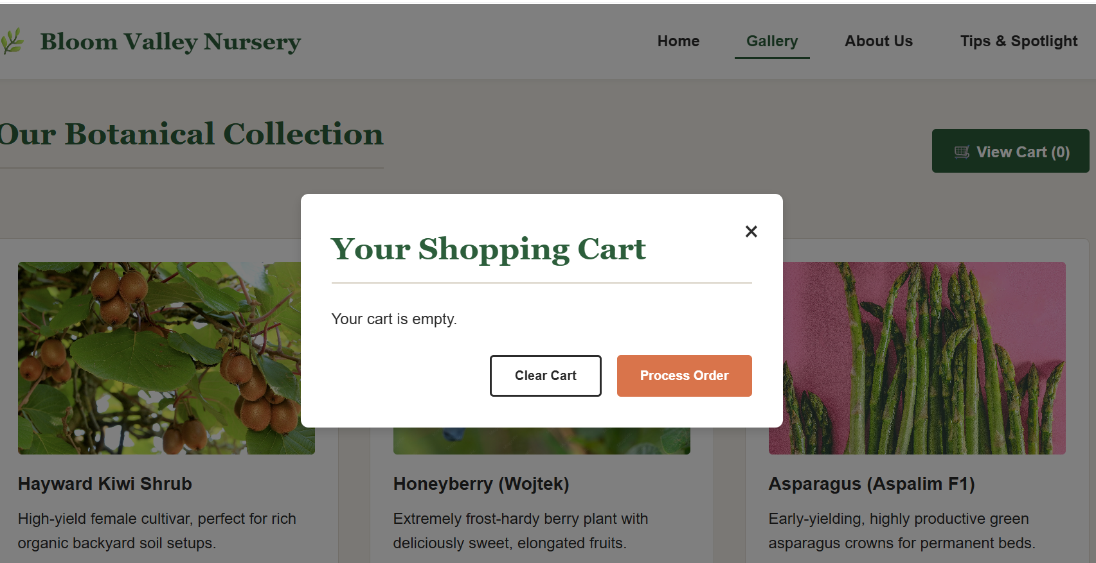

Clear Cart Button Analysis
Hint: Describe how the alert message for the Clear Cart button is triggered.
The "Clear Cart" routine empties the underlying tracking array, purges the browser storage keys, and triggers a full layout re-render inside the user interface modal. The "Process Order" action runs validation on cart data structures; if items are present, it launches the precise string alert required by the assignment parameters: alert("Thank you for your order.");, before resetting the state.

Rendered Process Order Button Alert Screenshot (Gallery Page)
Hint: Provide a screenshot showing the alert message that appears when clicking the “Process Order” button.
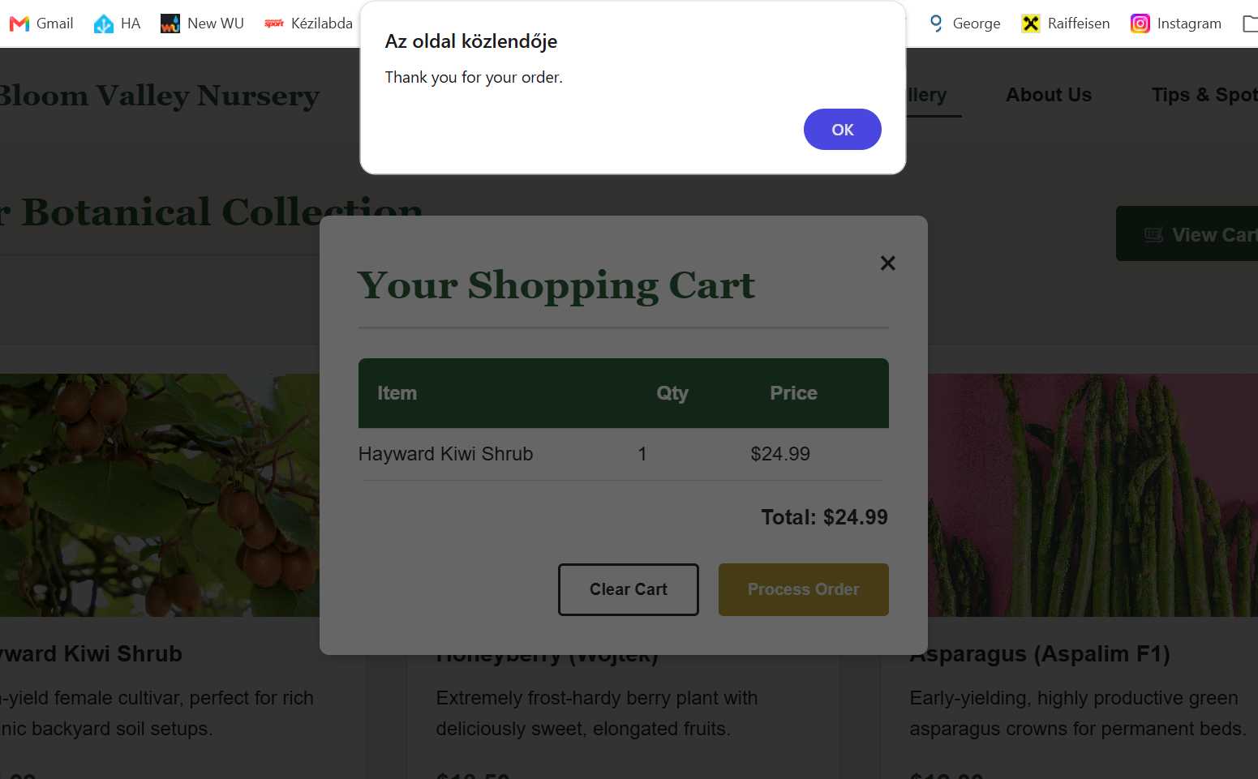

Process Order Button Analysis
Hint: Explain how you added the alert to the Process Order button.
I implemented a click event listener on the process order element via its unique identifier using processOrderBtn.addEventListener('click', ...) inside the cart module. Before triggering the alert, the handler executes a defensive validation check to ensure the cart data structure array length is greater than zero (cart.length === 0). If items are present, it invokes the synchronous native browser function alert("Thank you for your order."); to satisfy the explicit functional assignment criteria. Immediately following the alert acknowledgment, the script invokes state management routines to completely purge the tracking array, synchronize the data state backend to localStorage, update the layout count flags, and smoothly close the viewport modal container.

Rendered About Us/Contact Page Form Submission Alert Window Screenshot
Hint: Provide a screenshot showing the alert that appears when the Submit button is clicked on the Contact form.
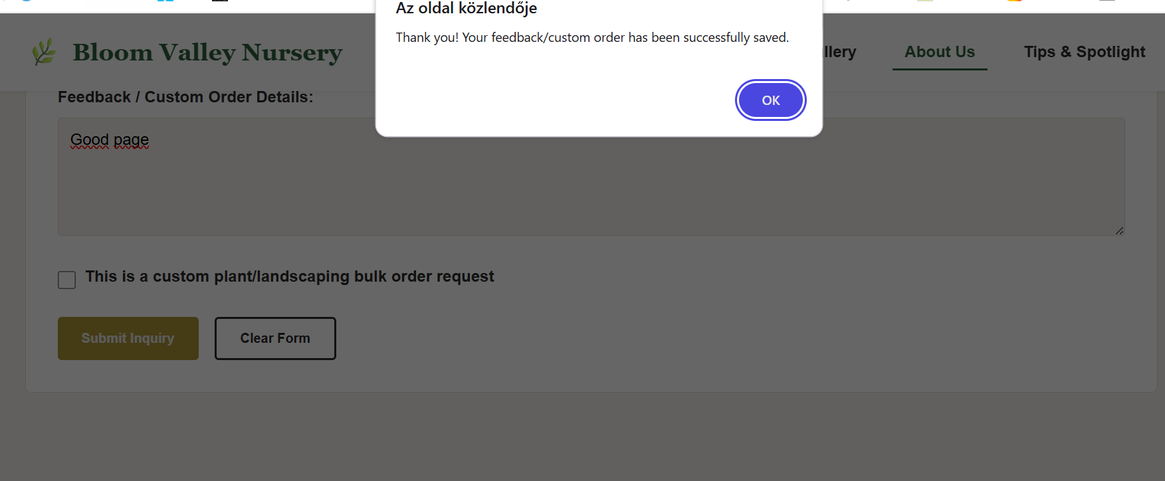

About Us/Contact Page Analysis
Hint: Describe how JavaScript is applied to the Contact page’s Submit button.
To add interactive capability to the contact form, I integrated a submit event handler targeting the document container via document.getElementById('feedback-order-form'). Rather than intercepting a simple button click event, binding directly to the form's submit event ensures that native HTML5 validation constraints (such as required field checking) execute automatically first.
Once the client inputs satisfy baseline syntactic requirements, the handler actively halts the default synchronous form dispatch postback via e.preventDefault(). It then invokes the synchronous native browser mechanism alert("Thank you! Your feedback/custom order has been successfully saved."); as a validation receipt. Immediately following user dismissal, the routine automatically executes lifecycle data operations: it clears transient user inputs from sessionStorage keys while maintaining structural identity states within localStorage, before cleanly execution a structural form reset via the form.reset() DOM interface.

Rendered About Us/Contact Page Input Validation Screenshot
Hint: Provide a screenshot showing any validation messages that appear if required fields are empty when the form is submitted. These messages are generated automatically by the browser through built-in HTML form validation. You do not need to write any JavaScript validation for this step.
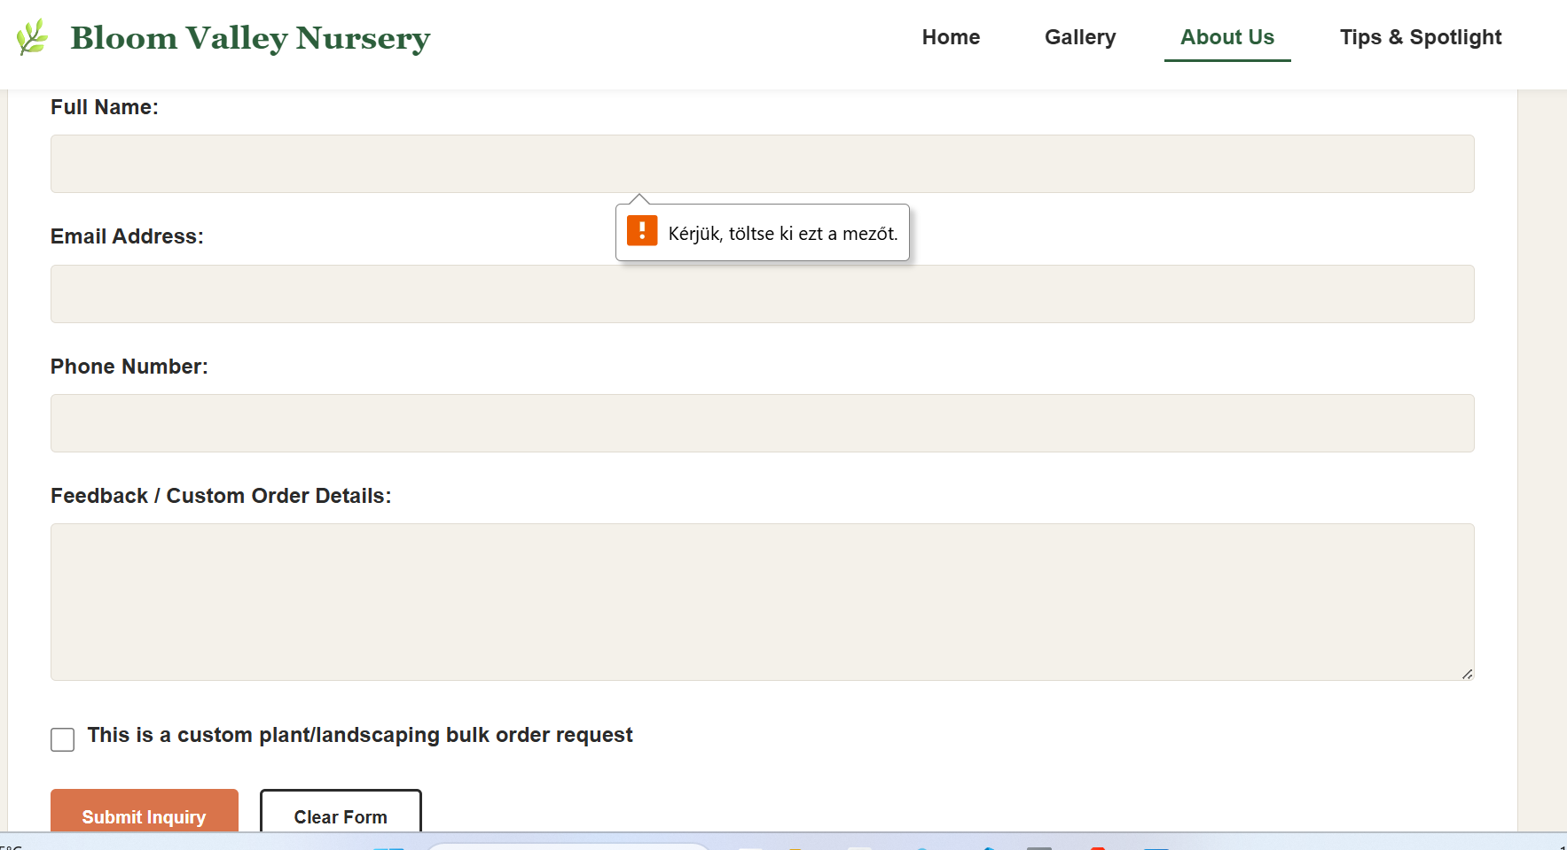

About Us/Contact Page Input Validation Analysis
Hint: Briefly describe what happens when the form is submitted with missing information. The validation messages you see are created by the browser because the form fields use HTML attributes such as required. No additional JavaScript is needed to produce these message.
When the contact and custom order form is submitted with missing or syntactically invalid data, the application utilizes native client-side constraints engine built directly into modern web browsers. Because the functional HTML input tags possess specialized inline attributes such as required and type="email", the browser automatically intercepts the execution stack before any custom JavaScript logic fires. It instantly cancels the event dispatch loop and displays a localized, accessible constraint validation bubble (e.g., "Please fill out this field") pointing directly to the empty or invalid input node. This design architecture guarantees immediate user feedback with zero processing overhead and ensures form data integrity prior to local data storage execution.

Testing and Error Reporting
Hint: Record any errors you encountered while writing or testing your JavaScript code. Describe how you attempted to fix them. If everything worked as expected, note that here.
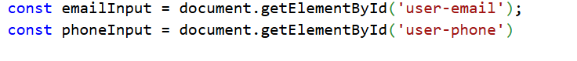
Forgot the „;” from the end of the line, later corrected it.

